|  |
| --- |
| **HEAT EXCHANGER PROJECT DESIGN REPORT**  **Christopher White**  **12/7/2014** |
|  |

|  |  |
| --- | --- |
|  | **HEAT EXCHANGER PROJECT DESIGN REPORT** |
| **TO:** | PROF. SMITH |
| **FROM:** | CHRISTOPHER WHITE |
| **SUBJECT:** | HEAT EXCHANGER PROJECT – DESIGN REPORT |
| **DATE:** | 12/7/2014HRISTATELYN O’CONNELL AND MICHAEL DUNCAN |

References:

1. Project.EES (EES file)
2. Parametric Tables

|  |  |  |  |
| --- | --- | --- | --- |
| L | N­­­L | S­­T | Total Cost |
| 4.907 m | 37 | 0.035 m | $11,6521 |

This memo displays the results of a parametric study that was performed in order to determine the optimal, cost efficient heat exchanger design based on the following parameters: length L, number of columns $N_{L}$, and transverse spacing $S_{T}$. The total cost included the cost of both the material and operation for a specified design life. The calculations for the analysis were conducted using an iterative process in EES. Based on the provided specifications, the following parameters were determined for the most cost effective heat exchanger in Table 1.

**Table 1: Design Specifications**

The heat exchanger was specified to be an unmixed cross-flow heat exchanger, using water to cool a 60% concentration of ethylene glycol. The ethylene glycol enters the tubes at 3 kg/s with an initial temperature of 100 C and exits at 10 C. Water at 1 atm with an inlet temperature of 5 C flows across the bank of aligned tubes with inlet velocity of 0.02 m/s. The heat exchanger has a maximum length of 5 m, height of 3.8 m, and depth of 2.1 m. The tubes are made of aluminum with an outer diameter of 2 cm and wall thickness of 2.5 mm. The heat exchanger has 40 rows with a longitudinal spacing of 5 cm between each column. The maximum and minimum limits of $N_{L}$ and $S_{T}$ were determined using the specified parameters above and the following equations:

$$Length=N_{L}× S_{L}$$

$$Height=N_{T}× S_{T}$$

The limits of $N_{L}$ were found to be between 0 – 42 columns, however only $N_{L}$ values between 37 – 42 columns were viable solutions. Based on the parameters listed in Table 1, the solutions yielded tube lengths that were applicable to the design criterion. The maximum $S_{T}$ was determined using the smallest and largest values for $N_{L}$. The minimum $S_{T}$ was determined using the following experimental relationship for unmixed cross-flow heat exchangers: $\frac{S_{T}}{S_{L}}$ $<0.7$, which states that any ratio of transverse spacing to longitudinal spacing below 0.7 is considered to be inefficient. The values for minimum and maximum transverse spacing for 37 and 42 columns are displayed in Table 1.

|  |  |  |
| --- | --- | --- |
| $$N_{L}$$ | $S_{T}$**(m)** | |
| Minimum | Maximum |
| **37** | 0.035 | 0.061 |
| **42** | 0.035 | 0.095 |

**Table 2: Minimum and Maximum Transverse Spacing for 37 and 42 Columns**

Before running the optimization, a working solution that could calculate the total heat transfer between the ethylene glycol and water was developed. Fluid properties were evaluated at the bulk mean temperature of the ethylene glycol. Using a thermodynamic heat transfer analysis, the total heat transfer of the ethylene glycol was determined. It is assumed that the same amount of heat is transferred to the water, therefore the exit temperature of the water could be calculated. The EES functions *PipeFlow* and *External\_Flow\_Inline\_Bank* were used to determine the heat transfer coefficients. For the internal flow analysis, it was assumed that the roughness factor had a minimal contribution on the heat transfer coefficient calculation. It was also assumed that the fouling factors had a negligible effect when using thermal circuit analysis to determine the overall heat transfer coefficient. Using the effectiveness-NTU analysis of a cross-flow unmixed heat exchanger, the heat transfer rate was determined using the following specified values: $N_{L}=25$, $S_{T}=7$ cm, and L = 1 m. This $\dot{q}$ is significantly lower than the $\dot{q}$ determined using the thermodynamic analysis, since the thermodynamic analysis only determines the amount of heat transfer that must take place for a system to reach equilibrium. The quantities: $\dot{q}=890524$ $W$, $U_{i}=106.9\frac{W}{m^{2}K}$, and ${\dot{q}}_{NTU}=371,546$ $W$ were the expected results using the following inputs: ${ N}_{L}=25$, $S_{T}=7$ cm, and L = 1 m. The EES code returned the same results, therefore validating the heat transfer calculations of the code.

With the working set of heat transfer calculations, the code was modified for optimization. A function was created to iterate over tube length based on the number of columns and transverse row spacing. An initial tube length of 100 m was guessed and the function would iterate until the guessed length and the solved length were within an error of ${10}^{-6}$ m. In order to determine pump work, equations were added to the code for the pump work for both the ethylene glycol and water using the pressure change across the tubes calculated using the *PipeFlow* and *External\_Flow\_Inline\_Bank* functions. It was assumed that the heat transfer by the effectiveness-NTU method would yield the same result as the thermodynamic heat transfer from ethylene glycol to the water. In order to test the validity of the EES code, the program was expected to calculate $U_{i}=84.14$ $\frac{W}{m^{2}K}$ and ${\dot{W}}_{pump}=2.596 W$ for the inputs ${ N}_{L}=25$, $S_{T}=7$ cm. The EES code returned expected results, therefore validating the portion of code written for optimization. Figure 1 displays an example of the output from the optimization EES code of pump work determined using 40 columns with varying transverse spacing.

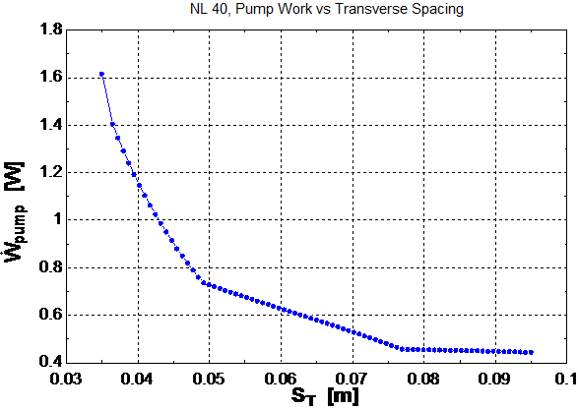

**Figure 1: Pump Work vs Transverse Spacing at 40 Columns**

P:\me_drive\steve and chris^2\Project #4\Pump Work vs NL.emf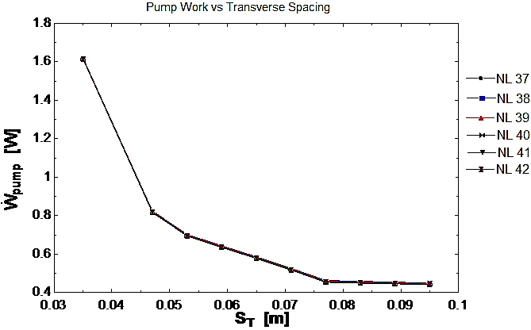

**Figure 2: Pump Work vs Transverse Spacing at Various Numbers of Columns**

**Figure 3: Pump Work vs Number of Columns at Various Transverse Spacing**

Figure 2 displays the output of the optimization EES code of the pump work for usable number of columns. As illustrated by the diagram, the number of columns has an insignificant effect on the pump work with varying values for transverse spacing.

Figure 3 displays the output of the optimization EES code of the pump work for values for transverse spacing with varying values for number of columns. The graph shows that pump work does not vary with increasing amount of columns. In both cases ${ N}_{L}$ has a small effect on pump work, whereas $S_{T}$ has a large effect. Because of this it will be easy to vary the number of columns and transverse length and solve for the actual length of each tube. Note that the usable number of column range is between 37 and 42 columns. The data plotted in this graph and the usable column range will be used to find the most cost effective solution. This cost is based on the material cost as well as the operation cost for 60 years.

Now that an acceptable range for number of columns has been determined, a parametric study was performed in order to determine the L, $N_{L}$ and $S_{T}$ that minimizes the total cost. This includes the cost of materials and cost of operation over the specified operation time. The following specifications for the material and operation costs provided by the customer. The material cost for the piping was $ 4.88 per foot of tubing. In order to calculate the operation cost, it was specified that the heat exchangerwas to have a design life of 60 years, running 50 weeks per year, 7 days a week, for 24 hours each day. The cost of electricity for the 60 years was assumed to be $ 0.30 per kW-hr. The total operation cost was determined using the operation specifications and the total pump work determined in the previous analysis. A parametric table was created to determine the values of L, ${ N}_{L}$, $S_{T}$, andtotal cost using the same iterative process used in the previous analysis with the addition of the calculations for total cost.

*P:\me_drive\steve and chris^2\Project #4\Total Cost vs L.emf* Figure 4 displays the variation of the total heat exchanger cost as tube length increases for each of the number of columns within the acceptable range of values. It can be seen that 37 columns is least expensive at the max tube length of ~5 m since the cost is ~$118,500. While it is more cost effective to have smaller number of columns, a longer length for each tube is required.

**Figure 4: Total Cost vs Tube Length at Various Numbers of Columns**

P:\me_drive\steve and chris^2\Project #4\Total Cost vs ST.emfP:\me_drive\steve and chris^2\Project #4\Total Cost vs NL.emf

**Figure 6: Total Cost vs Transverse Spacing at Various Numbers of Columns**

**Figure 5: Total Cost vs Numbers of Columns with Respect to Increasing Transverse Spacing**

Figure 5 displays the total cost for each number of columns as transverse spacing increases. Figure 6 shows the total cost for transverse spacing for each number of columns. Both figures show an increase in total cost as transverse spacing increases.

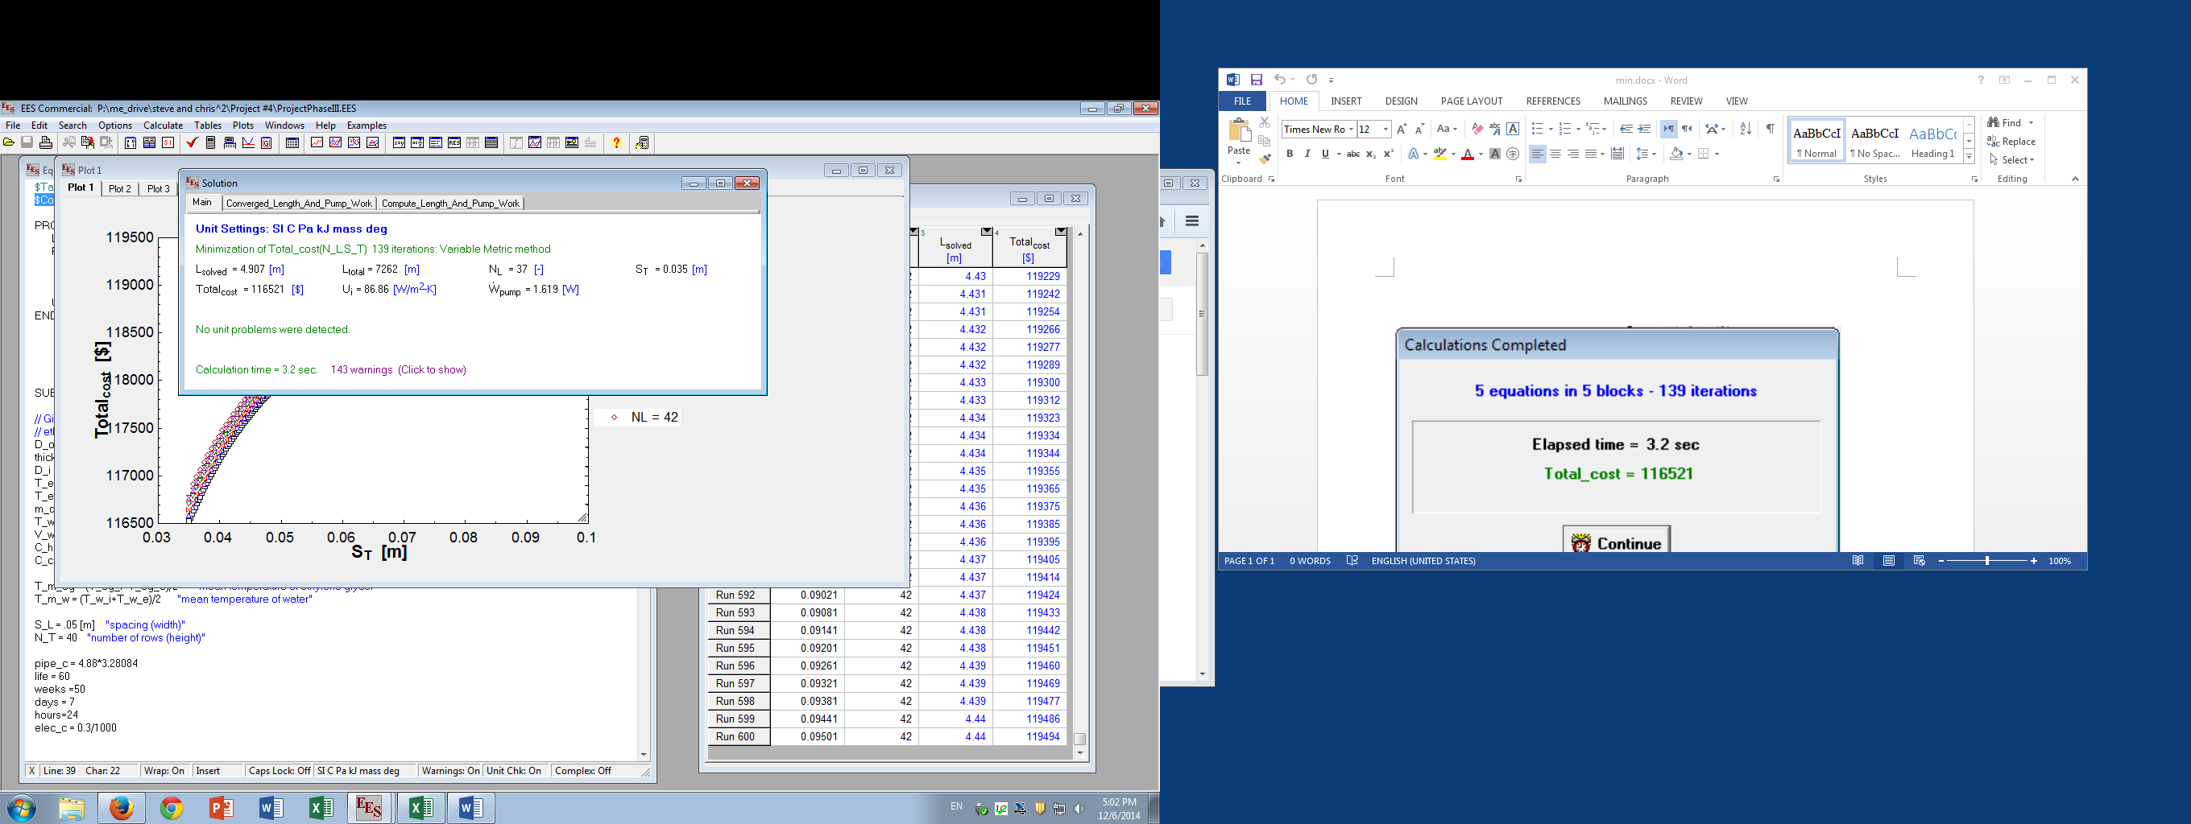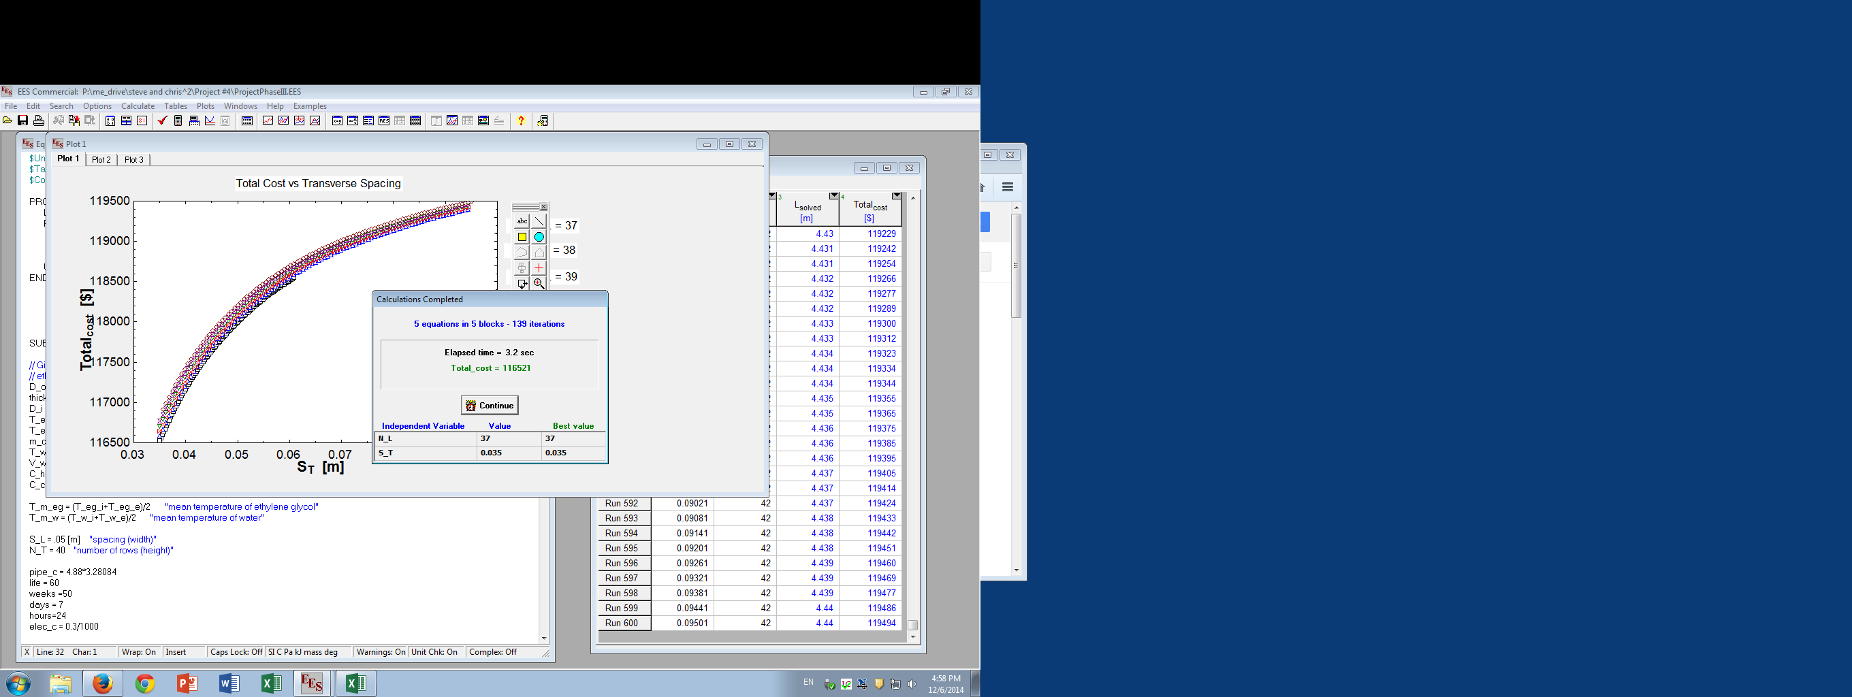 In order to minimize the total cost of the heat exchanger, the values of NL and ST were minimized in EES using the *Find Minimum or Maximum* function. The bounds were set to the values listed in Table 2. This produced the following solutions displayed in Figure 7.

**Figure 6: Minimized Values of NL and ST Using Find Minimum or Maximum**

The parameters found above were calculated for the ideal design in order to cool the ethylene glycol to a specified exit temperature of 10 C. A parametric study was performed to determine the effects of deviances in both the mass flow rate of the ethylene glycol entering the tubes and the inlet velocity of the water across the bank of tubes. The EES code was rewritten to solve for the exit temperature of the ethylene glycol rather than solving for the length of the tubes. Figure 7 displays the results after the code was modified to solve for the temperature by varying the mass flow rate of the ethylene glycol from 1 to 5 kg/sec. After the flow rate reaches ~2 kg/s the exit temperature increases at a steady rate. Figure 8 displays the results after the code was modified to solve for the temperature by varying the inlet velocity of the water from 0.01 to 0.04 m/sec. Note that the exit temperature significantly drops at an inlet velocity of ~0.0325 m/sec, presumably due to a transition from laminar to turbulent flow of the water across the bank of tubes. Therefore small variations in both the mass flow rate of the ethylene glycol and the inlet velocity of the water have an insignificant effect of the exit temperature of the ethylene glycol.

P:\me_drive\steve and chris^2\Project #4\Phase 4 M vs T.emfP:\me_drive\steve and chris^2\Project #4\Phase 4 Vw vs T.emf

**Figure 7: Exit Temperature of Ethylene Glycol Depending of Mass Flow Rate of Ethylene Glycol**

**Figure 8: Exit Temperature of Ethylene Glycol Depending of Inlet Velocity of Water**